Dear Parents & Carers,

Please note advice from South Gloucestershire in relation to rising cases. This recommends that children do not attend school when unwell, whether their symptoms are those of COVID or otherwise.

"We maintain that schools and settings in South Gloucestershire should follow the current government guidance; that it remains children do not attend school when unwell as has always been the case – symptoms can be an indicator of a whole range of infections that can spread through contact with others. If symptoms develop into one of the three cardinal Covid-19 symptoms isolate and get tested e.g. a high temperature; a new, continuous cough; a loss or change to your sense of smell or taste. This advice has not changed and we ask parents to remain vigilant."

Please support us to maintain the good health of all pupils attending school by keeping them at home if they are in any way unwell.

Best wishes,
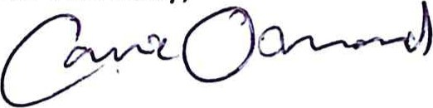
Carrie Osmond
Headteacher

